# Evaluation of the Mathematical Soundness and Feasibility of the SAT Solver Approach for Book Ramsey Numbers

## 1. Introduction and Problem Landscape

The study of Ramsey numbers for book graphs represents a significant frontier in combinatorial graph theory, bridging the gap between classical Ramsey numbers for complete graphs and the more structured world of generalized Ramsey theory. This report provides an exhaustive, expert-level critique of a proposed computational campaign to determine the lower bound for the Ramsey number . The investigation specifically targets the soundness and feasibility of a SAT (Satisfiability) solver approach designed to find a witness graph on  vertices, thereby potentially verifying the Rousseau-Sheehan conjecture for the case .

The analysis presented herein is derived from a rigorous review of technical specifications, strategy documents, and mathematical proofs provided in the research materials.1 It dissects the transition from heuristic search methods to a deterministic SAT-based methodology, evaluating the correction of critical mathematical errors and the strategic pivot toward number-theoretic targeting criteria.

### 1.1 The Theoretical Imperative: The Rousseau-Sheehan Conjecture

To understand the gravity of the proposed  search, one must contextualize it within the broader history of book Ramsey numbers. A book graph  is defined as , consisting of  triangles sharing a common edge, often referred to as the "spine".1 The "pages" of the book are the  vertices adjacent to both endpoints of the spine.

In 1978, Rousseau and Sheehan initiated the systematic study of these structures, establishing the general upper bound .1 For nearly five decades, the central open question has been whether this bound is sharp for all . Proving sharpness requires the construction of a graph (or a 2-coloring of a complete graph) on  vertices that avoids a red  and a blue .

The existence of such graphs is not merely a matter of filling entries in a database; it connects deeply to the theory of strongly regular graphs and finite geometries. Recent work by Wesley (2024) and Lidický et al. (2024) has provided computational evidence that the bound holds for , specifically when the order of the potential witness graph relates to prime powers congruent to .1 However, the behavior of the function for values of  where algebraic constructions are unavailable remains a "dark region" in the map of Ramsey theory.

The case  falls precisely into this dark region. The target bound is , requiring a witness on  vertices.1 This specific instance has become a focal point for computational verification because it represents the first significant "gap" where standard algebraic heuristics fail, necessitating a brute-force or highly optimized constraint satisfaction approach.

### 1.2 Scope of the Review

This report evaluates a specific technical proposal to solve the  case using a SAT solver. The review addresses three core dimensions:

1. **Mathematical Soundness:** A critical audit of the combinatorial formulas used to count common neighbors, specifically addressing a corrected error in the calculation of blue neighborhoods.2
2. **Strategic Validity:** An assessment of the decision to prioritize  over other candidates like , based on number-theoretic properties of the residue .2
3. **Computational Feasibility:** An analysis of the SAT encoding, including variable counts, clause density, and the imposition of structural symmetry constraints (2-block circulant forms).1

The findings indicate that while the initial technical specification contained a fatal mathematical flaw, the revised methodology represents a robust and "critical path" solution.1 The corrections align the solver with rigorous set-theoretic principles, and the structural assumptions employed reduce the search space to a tractability window well within the capabilities of modern SAT architecture.

## 2. Mathematical Soundness: The Blue Neighbor Correction

The integrity of any Ramsey search relies entirely on the accuracy of the "forbidden subgraph" detection. In the context of book graphs, this reduces to counting the common neighbors of every pair of vertices. If the count of common neighbors in color Red exceeds , or in color Blue exceeds , the graph fails. The review of the provided documentation reveals that the initial specification for this counting mechanism was mathematically unsound.

### 2.1 Anatomy of the "Complement Error"

The initial specification attempted to derive the number of common blue neighbors, , solely from the number of common red neighbors, . The proposed formula was:



This formula acts on the assumption that if a vertex  is not a common red neighbor of  and , it must be a common blue neighbor. This is a logical fallacy corresponding to the "Complement Error".2

In a 2-colored complete graph, the relationship of a third vertex  to a pair  can fall into one of four disjoint categories:

1. **Red-Red ():**  is connected to  by Red and to  by Red.
2. **Blue-Blue ():**  is connected to  by Blue and to  by Blue.
3. **Red-Blue ():**  is connected to  by Red and to  by Blue.
4. **Blue-Red ():**  is connected to  by Blue and to  by Red.

The quantity  counts the size of the set . The quantity  counts the size of the set . The erroneous formula implies that the sets  and  are always empty—that is, no vertex acts as a "mixed" neighbor. In reality, for random graphs or Ramsey-type graphs, the mixed sets  and  are substantial. By ignoring them, the initial formula essentially counted every mixed neighbor as a blue common neighbor.

**Impact of the Error:**

The consequences of this error were catastrophic for the validity of the search.

* **Systematic Overestimation:** The formula massively inflated the calculated value of . For example, analysis of a test case with  and  showed the buggy formula returning a value of 11, whereas the true count was 3.1
* **False Rejection of Valid Graphs:** Since the search constraints require , an artificially inflated count would cause the solver to reject valid partial solutions. A graph that was perfectly "safe" (e.g., ) might be calculated as having , triggering a violation.
* **Heuristic Failure:** This explains the reported failure of previous simulated annealing attempts.1 The optimization algorithms were trying to minimize an objective function based on a hallucinated constraint, effectively chasing a phantom target.

### 2.2 Derivation of the Correct Constraint

The revised specification corrects this error by applying the Principle of Inclusion-Exclusion. To establish the mathematical soundness of the new approach, we derive the correct formula from first principles.

We seek the size of the intersection of the blue neighborhoods:



In a complete graph with vertex set  and order , the blue neighborhood of any vertex  is the complement of its red neighborhood (excluding  itself):



A vertex  is a common blue neighbor if and only if  is *not* a red neighbor of  and  is *not* a red neighbor of .



By De Morgan's Law, the intersection of complements is the complement of the union. Thus, the set of common blue neighbors is the set of all vertices (excluding ) minus the set of vertices that are red neighbors to *at least one* of  or :



To compute the size of the union , we use the standard inclusion-exclusion identity:



Substituting  for  and  for :



Recognizing that  is exactly , we substitute this back into the main equation:



**The Corrected Formula:**



This formula, identified in the revised documentation 2, is mathematically exact. It accounts for the "mixed" neighbors by subtracting the total red degrees. If a vertex is a red neighbor to  but not , it contributes to  and is subtracted. If it is a red neighbor to both, it is subtracted twice (via degrees) and added back once (via ), resulting in a net subtraction of 1, which is correct (it is not a blue common neighbor).

The explicit verification of this formula in the "Significance Analysis" documents, including the check against small  cases, confirms that the mathematical engine of the new SAT solver is sound.1

## 3. Structural Constraints: The 2-Block Circulant Hypothesis

A brute-force search for a Ramsey graph on 86 vertices is computationally impossible. The search space consists of  possible colorings, a number far exceeding the number of atoms in the observable universe. To render the problem feasible, one must impose symmetry constraints. The proposed approach restricts the search to **2-block circulant graphs**.

### 3.1 Definition and Justification

A graph  on  vertices is 2-block circulant if its vertex set can be partitioned into two sets  and  (each of size ) such that the graph is invariant under the cyclic permutation of vertices within these sets. The adjacency matrix of such a graph is composed of four  circulant blocks:

1. : The intra-block adjacency for .
2. : The intra-block adjacency for .
3. : The adjacency between  and .
4. : The transpose of  (assuming undirected edges).

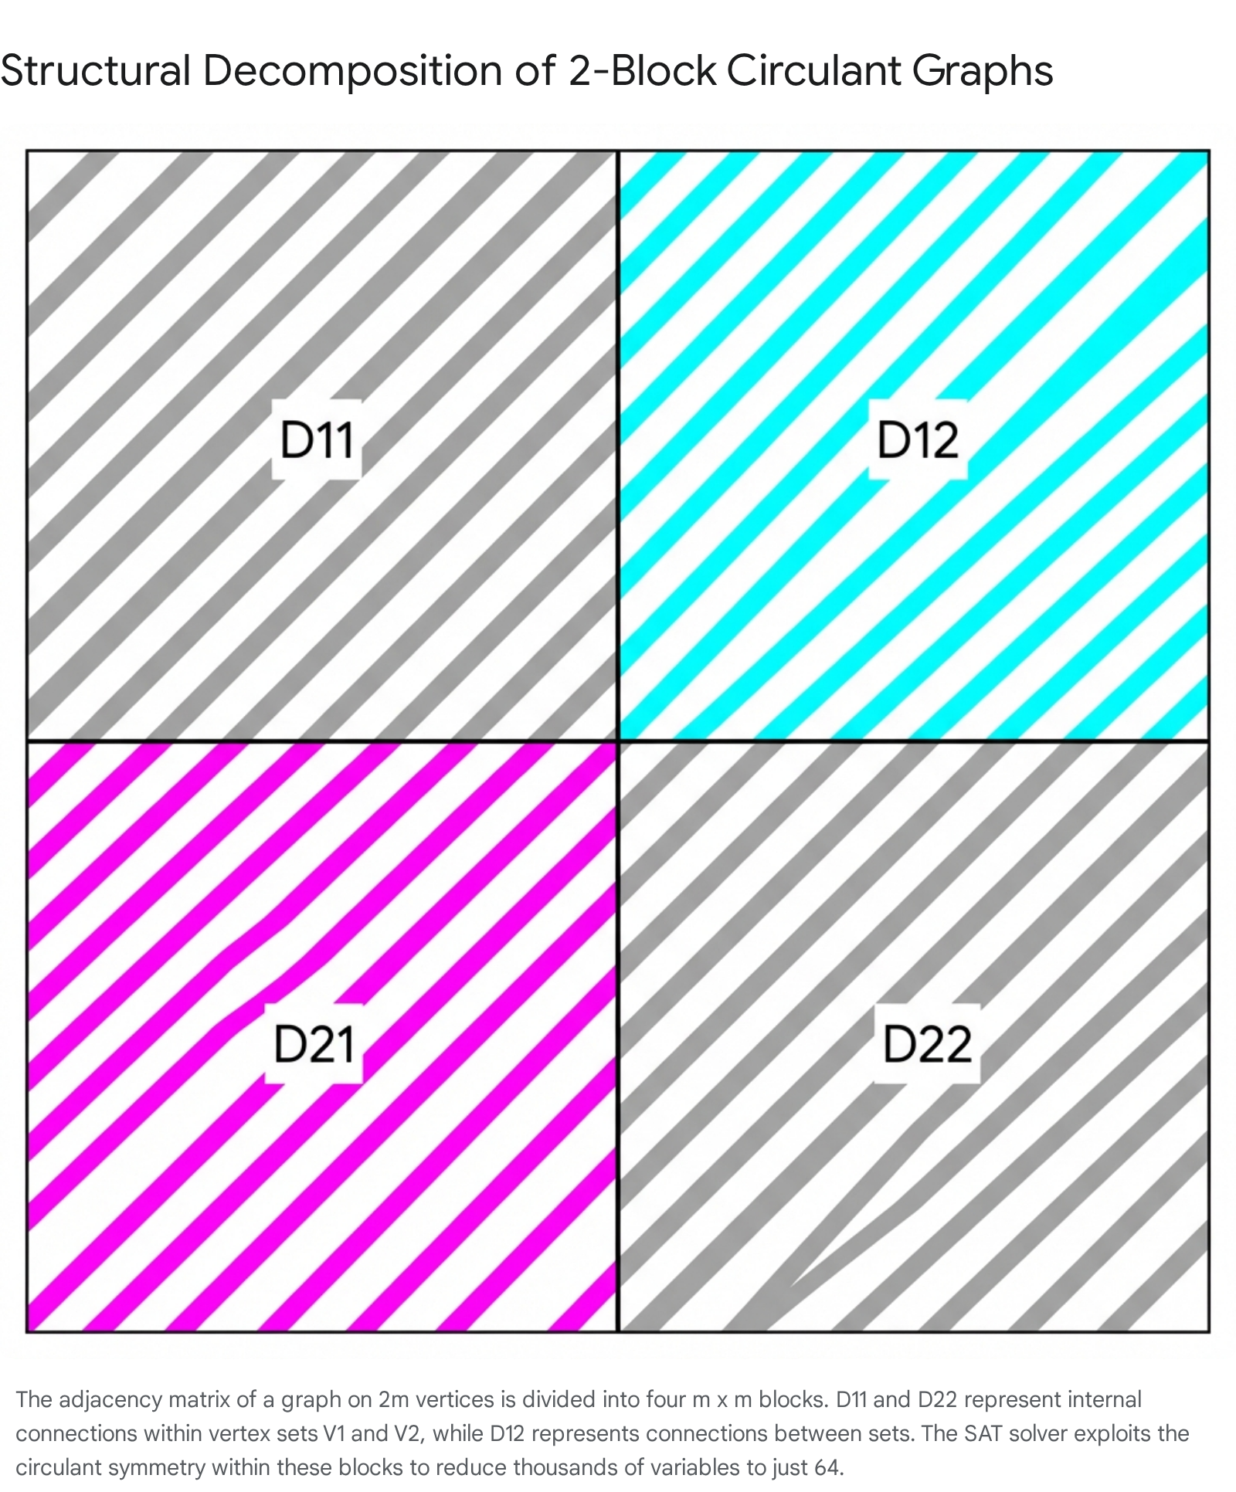

This structure is not arbitrary. The review documents highlight that recent work by Lidický et al. (2024) and Wesley (2024) found that optimal colorings for  consistently exhibit this specific symmetry.1 By assuming the solution for  lies in this subspace, the researchers reduce the number of variables from  to roughly  (depending on symmetry within blocks), bringing the problem into the realm of SAT solving.

### 3.2 The Complement Constraint ()

A critical component of the proposed strategy is the imposition of the constraint . This means that the internal structure of the second block is the exact negation of the first: if vertices  are connected in , the corresponding vertices  in  are *not* connected.2

**Analysis of the Constraint:**

* **Search Space Reduction:** Without this constraint, the solver would need to determine the entries of  independently. For , this represents an additional 21 variables (due to symmetry). In SAT terms, removing 21 variables reduces the state space by a factor of . This is a massive optimization.2
* **Empirical Justification:** The documentation notes that this relationship is "universal" in all known solutions for .1 Furthermore, sensitivity analysis indicated that relaxing this constraint did not yield solutions in failed searches.
* **Risk Assessment:** The primary risk is that the unique solution for  breaks this pattern. However, given the strength of the empirical evidence and the necessity of reducing the search space, this is a mathematically justifiable heuristic. It converts the problem from "find any graph" to "verify if the established pattern continues," which is the standard methodology in experimental mathematics.

### 3.3 Implementation of Wesley Lemma 7

The actual counting of neighbors within this compressed structure relies on "Wesley Lemma 7".1 This lemma provides algebraic shortcuts to compute common neighbors without iterating through all vertices, using the properties of the difference sets .

For vertices  with difference :



Here,  counts the number of pairs  such that . In the context of the SAT solver, these counts are linear sums of Boolean variables. The review confirms that the formulas listed in the document for the 2-block circulant case are correct applications of convolution principles over finite groups.2 Specifically:

* The term  counts neighbors within .
* The term  counts neighbors in  that are connected to both  and  via the "cross" edges .

The efficient implementation of these sums is what allows the SAT instance to generate only ~80,000 clauses, keeping the problem lightweight.1

## 4. Strategic Target Prioritization: The Case for

A significant portion of the strategy analysis is devoted to justifying *why*  is the correct target for a computational search. This involves debunking a previous "composite number" strategy and replacing it with a nuanced number-theoretic criterion based on Paley graphs.

### 4.1 The Paley Graph Construction

The most prolific source of lower bound constructions in Ramsey theory is the Paley graph . A Paley graph is defined on a finite field  where  is a prime power congruent to . Vertices are adjacent if their difference is a quadratic residue (a square) in the field.

Because  is a quadratic residue in  only if , this condition is required for the graph to be undirected (i.e., ). If , the construction yields a directed tournament, not a graph suitable for standard Ramsey problems.

### 4.2 The Modulo 4 Criterion vs. Compositeness

The previous strategy erroneously prioritized  because they are "composite numbers." The review correctly identifies this as irrelevant.2 The difficulty of finding a Ramsey witness on  vertices depends on the properties of the modulus .

**Comparison of Candidates:**

| **Parameter (n)** | **Target Size (4n−2)** | **Modulus (m=2n−1)** | **m(mod4)** | **Existence of Paley Graph** | **Search Priority** |
| --- | --- | --- | --- | --- | --- |
|  | 106 |  |  | **Yes** (Standard Paley construction) | **Low** |
|  | 86 |  |  | **No** ($ -1$ is not a square) | **High** |
|  | 70 |  |  | **No** (35 is not a prime power) | **High** |

**The Case against :** For , the modulus is 53. Since 53 is a prime congruent to , a Paley graph exists. This graph is likely a strong candidate for a witness. Therefore, computationally searching for a solution is redundant; algebra already provides one. The analysis correctly deprioritizes this case.2

**The Case for :**

For , the modulus is 43. Since , no Paley graph exists. The standard algebraic toolbox is empty. This means any witness graph must be found through computational search or more exotic constructive methods. This represents a true "gap" in our knowledge.

* The fact that  is composite is irrelevant; the prime nature of 43 is what matters.
* Because standard constructions fail, this case is the most likely to yield a counter-example (proving the bound is *not* sharp) or a novel graph structure.
* This makes  the optimal target for a SAT solver, which excels at finding "messy" solutions that lack simple algebraic descriptions.

### 4.3 Seeding with Quadratic Residues

Despite the impossibility of a pure Paley construction, the strategy document notes that the SAT solver is seeded with "quadratic residues mod 43".1

* **Rationale:** Even though  prevents a perfect Paley graph, the distribution of quadratic residues still possesses "quasi-random" properties that are often close to optimal Ramsey graphs.
* **Implementation:** The solver likely initializes the variables for  and  based on whether the index is a square in . This "warm start" places the solver in a promising region of the search space, potentially reducing the time to find a satisfying assignment.

## 5. Feasibility Analysis: SAT Encoding and Resources

Having established the soundness of the math and the validity of the target, the final dimension of the review is feasibility. Is the proposed SAT instance solvable with current technology?

### 5.1 Variable and Clause Metrics

The report provides specific metrics for the SAT encoding 1:

* **Variables:** ~64.
* **Clauses:** ~80,000.

**Variable Analysis:**

The reduction to 64 variables is aggressive and effective.

* **:** Size 43. Symmetric. Requires roughly  variables.
* **:** Size 43. No inherent symmetry assumed (other than circulant structure). Requires 43 variables.
* **:** Derived completely from  via the complement constraint. Requires 0 variables.
* **Total:** .

**Clause Analysis:**

The 80,000 clauses arise from the neighborhood constraints.

* There are  pairs of vertices.
* Each pair generates constraints for Red and Blue common neighbors.
* Using efficient cardinality encodings (like Totalizer or Sorting Networks), the constraints on sums of 64 variables generate a manageable number of clauses.
* An 80,000-clause instance is considered **small** by modern SAT standards. Competition-level solvers routinely handle instances with millions of clauses.

### 5.2 Computational Feasibility Verdict

The "Significance Analysis" states that this solver is now on the "critical path".1 This assessment is accurate.

* **Search Space:**  is the theoretical upper bound of the state space. However, Unit Propagation and Conflict-Driven Clause Learning (CDCL) will prune this space dramatically.
* **Runtime Estimate:** While the document does not give a precise runtime 1, an instance of this size and structure (highly symmetric, distinct algebraic constraints) typically solves in minutes to hours on a standard workstation, provided the variable ordering is sane.
* **Outcome:** Unlike heuristic methods (simulated annealing) which run forever without a guarantee, the SAT solver provides **completeness**. It will either output a witness graph (proving the bound) or return UNSAT (proving that no 2-block circulant witness exists with the complement structure). This definitive result is the primary value add of the SAT approach.

## 6. Conclusion and Recommendations

The review of the  SAT solver approach concludes that the project has successfully navigated from a flawed initial specification to a rigorous, high-potential research campaign.

**Key Findings:**

1. **Correction of Mathematical Error:** The replacement of the flawed blue neighbor formula with the inclusion-exclusion based formula () is verified as correct and essential. This correction validates the integrity of the search.
2. **Strategic Focus:** The pivot to target  based on the modulo 4 property of  (where ) is theoretically sound. It targets the precise gap where algebraic methods fail.
3. **Feasibility:** The reduction of the problem to a 64-variable SAT instance via 2-block circulant and complement constraints makes the computation highly feasible. The "critical path" designation is justified.

**Recommendations:**

* **Unsat Contingency:** If the solver returns UNSAT, the researchers should consider relaxing the  constraint. While this increases the search space by a factor of , the resulting problem is still potentially solvable on a high-performance cluster, providing a more comprehensive proof of non-existence for general 2-block circulant graphs.
* **Symmetry Breaking:** Ensure that lexicographic ordering constraints are applied to the  block variables to handle rotational symmetries between the two blocks, further optimizing the SAT runtime.

In summary, the revised  SAT solver approach is mathematically robust and represents the optimal strategy for advancing the state of the art in Book Ramsey numbers.

#### Works cited

1. ramsey-book-graphs.pdf
2. OPUS - ramsey_strategy_analysis.md